1. Open browser and search virtual box and download it
2. Install the virtual box

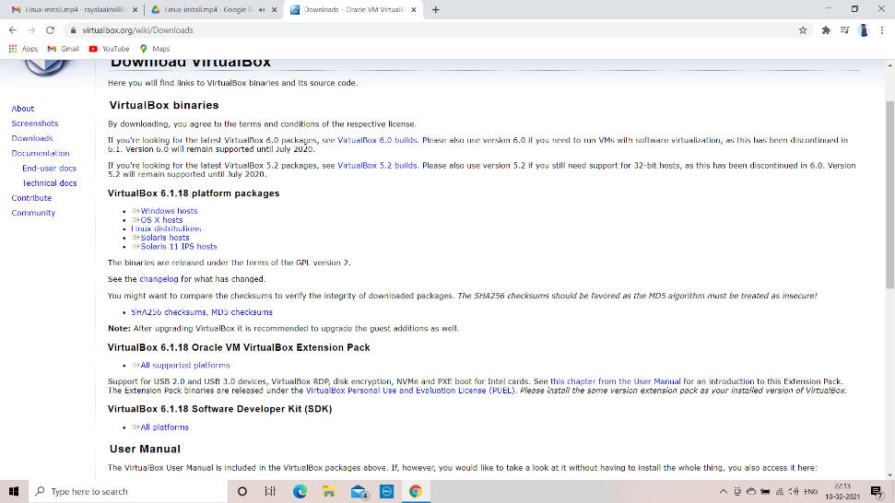

1. Open the virtual box 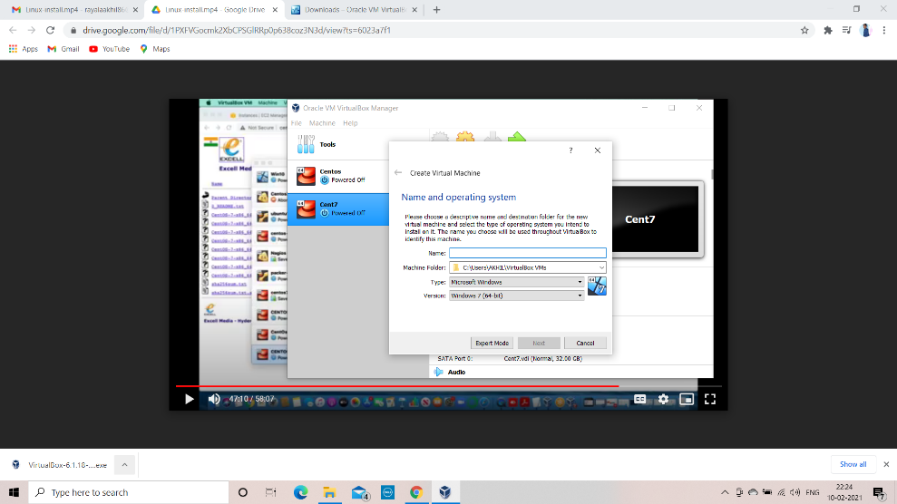
2. After installation create a operating system
3. Select the sixe
4. Select the hard disc

